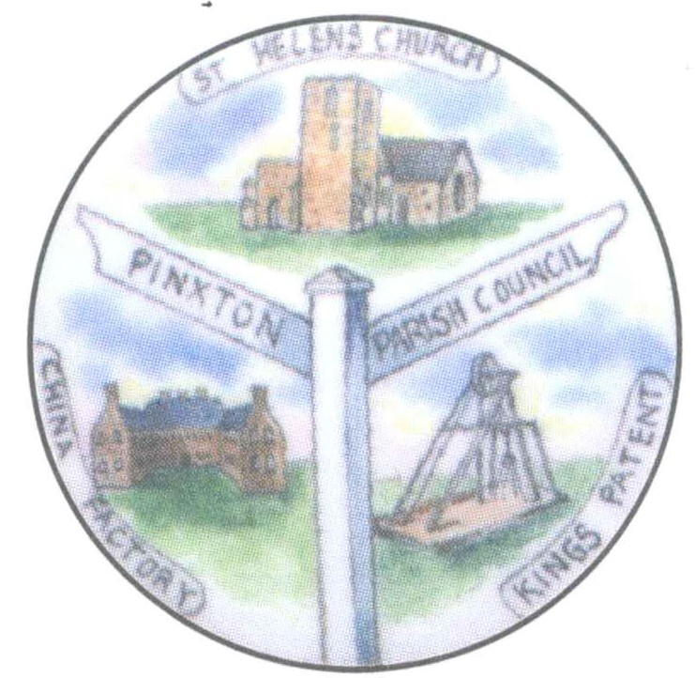

Minutes of the Extraordinary Parish Council Meeting held on
9th February 2022 at 7pm in the Village Hall
Present:
Cllr M Hinman (Chairman) Cllr J Siddle Cllr V Meredith Cllr B Kelly Cllr S Fox
L J Powell – Parish Clerk
Members of the Public x 3

21/252 Apologies for absence
Apologies were received from Cllrs Brentnall and Brockman who were unwell, Cllr Chippington who had university commitments, Cllr Dooley who was on vacation and Cllr Marshall who had a previous engagement. These apologies were recorded and accepted.
No apologies were received from Cllrs Coyle or Street.

21/253 Declaration of Members Interest/Update of Register
There were no declarations.

21/254 To receive and approve requests for dispensations from members on matters in
which they have a Disclosable Pecuniary Interest.
There were no requests for dispensation.

21/255 To determine which items, if any, should be taken with the public excluded.
It was agreed that no items needed to be taken with the Public and Press excluded in
accordance with the Public Bodies (Admission to Meetings) Act 1960, S1.

21/256 Public Speaking
256.1 Parishioner Matters
There were no parishioners who wished to speak at this time, but the Chairman agreed, on this occasion, to permit speaking at pertinent points during the meeting.
256.2 Police Matters
There was no police representative present.
256.3 Reports from Council Representatives on Outside Bodies
There were no reports from members of outside bodies.
256.4 Reports from District and County Councillor Representatives on matters of direct relevance to Pinxton Parishioners
There were no reports for this meeting.

21/257 Queens’ Platinum Jubilee Celebrations
Consideration was given as to how the village should celebrate the Queens’ Platinum
Jubilee.
The ideas of councillors and the Clerk were discussed at length. It was agreed that the parish
council should do as much as possible for the village on this special occasion.
After much deliberation, the following resolution was made:
RESOLVED (unanimous)
- A maximum budget of £30,000 be set with the Clerk applying for grants to offset costs.
- Large banners be purchased to span the streets.
- A congratulatory letter be sent to Buckingham Palace from the Chairman.
- Prices be sought for the hire of a cherry picker and operator to put bunting up around the village.
- The 70th design 50pence piece be awarded to all children attending school in Pinxton. Chairman to deliver them.
- 70 trees to be planted around the village with protective metal cages around.
- A mosaic to be done by the four schools. Each do one equal sized piece with the council then framing the entire ensemble and displaying on the village hall.
- The agreed mural to have a Platinum Jubilee banner at the top.
- A large, engraved stone planter was agreed in principal with site to be arranged.
- The Chairman of the council will judge the best dressed house.
- Thursday: Afternoon Tea for senior citizens with Sing Along with Ellie at the VH. F.O.C. but must be by ticket only, 70 people permitted.
- Friday: Village Hall Funday/Community Picnic. Entertainment and games, Norman Taylor be asked to do a display. In the evening a Mowtown night for adults only, 140 people allowed, food will be provided. This event is F.O.C. but by ticket only. Cllr Hinman to arrange food and entertainment.
- Saturday Funfair with fireworks, rides, food, entertainment etc. Kirkstead road closure from top down to Wilson Street.
- Sunday A church service followed by refreshments at the VH with a band. The mural a the gable end of the VH will then be unveiled.
- T.B.A. Football match between Pinxton and South Normanton.

21/258 Date of the next Ordinary Parish Council meeting – 16th February 2022 7pm in The Village Hall, 3 Kirkstead Road, Pinxton, NG16 6NA

Meeting closed 8.40pm

Signed Chairman…………………………………………………………………. (Cllr Hinman)

